Working With Dataset

# Loading The Dataset

|  |  |
| --- | --- |
| Team ID | PNT2022TMID04535 |
| Project Name | Visualizing and Predicting Heart Diseases with an Interactive Dashboard |

## Dataset Link:

<https://www.kaggle.com/datasets/rishidamarla/heart-disease-prediction>.

## About Dataset:

This is a kaggle dataset. It contains 14 fields. The goal of the dataset is to predict the presence of heart disease.

## Loading the dataset into Cognos Analytics:

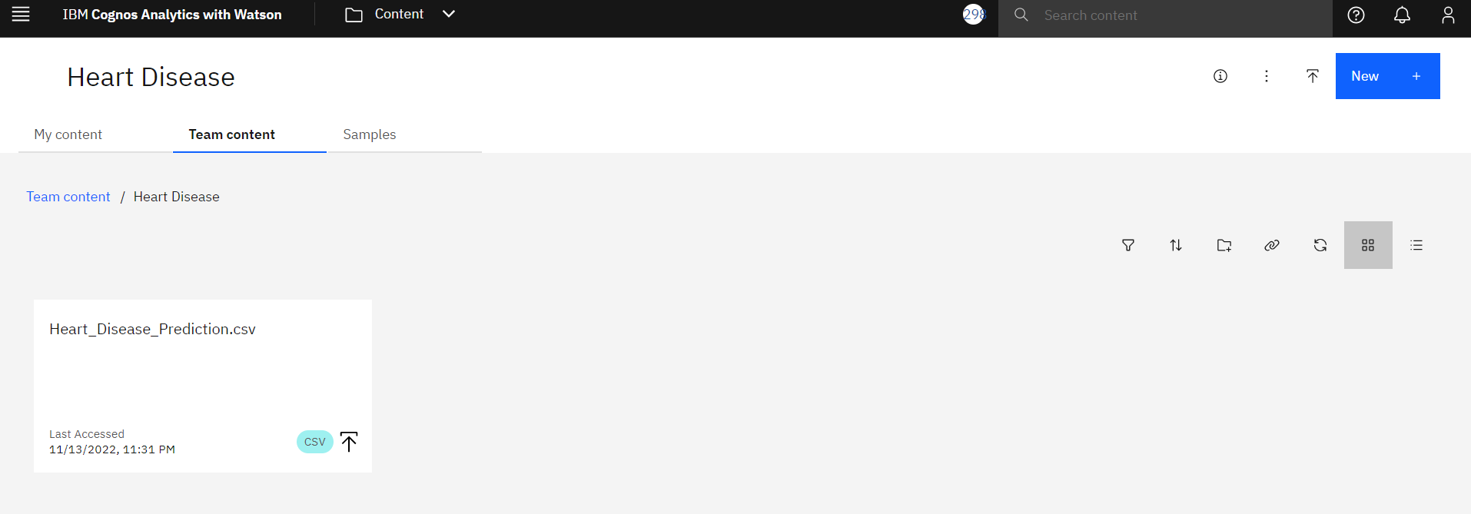

## Steps:

1. Open Menu
2. Content → Team Content → New Folder → Heart Disease.
3. Inside the folder Heart Disease → Upload Data → Select the dataset to upload.